Sibin Jacob
Bellevue University
CYBR 545 White Collar Crime
SQUID GAME TOKEN (MILESTONE 5)

Squid Game Token – Milestone 5 Term Project
Introduction
The Squid Game cryptocurrency scam was a fraudulent scam that took place in November 2021, inspired the TV Netflix series “Squid Game”, which premiered around that same time. This scheme capitalized on the popularity of the show, deceived investors through a rug-pulling scheme, leaving many investors with significant losses (Brooks, 2021). This paper analyzes the scam’s mechanics, the loopholes exploited, and investigative measures taken to identify the perpetrators.
Case Background
The coin was titled as the “Squid Game Coin” (SQUID). The creators presented the coin as a play-to-earn game, an opportunity for fans to play a fan-made online game, where participants can play the same kinds of children games presented in the show after their investment in the coin. Investors were led to believe the coin will grant them access to the game where they can win real life prize money. However, no such game existed, as it was a fabrication designed to appeal buyers. Unfortunately, the individuals have not been identified, but this case is still being kept an eye on in hopes of revealing their identity one day.
The key players include:
- Anonymous developers who created the coin’s smart contract to manipulate investors.
- Media outlets and crypto influencers who unintentionally fueled hype.
- Victims who invested in the coin based on misleading and false information.

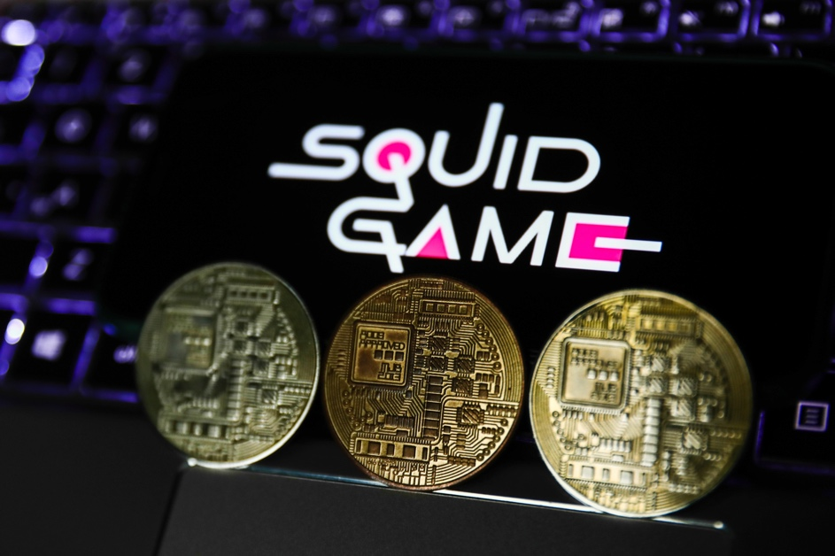
Coin used for advertisement

Media Influence
The Squid Game coin was fueled by mainstream media outlets to amplify the hype. Many social media influencers and news articles promoted the coin without confirming its legitimacy. Social media played a critical role in why and how this scam happened. When investors saw the popularity, they assumed the project was legit. Different theme cryptocurrencies and meme coins were trending. The perpetrators of the Squid Game Coin took advantage of that popularity of the Netflix series to attract investors.

Developers’ Smart Contract
The Squid Coin was programmed with a smart contract by the developers, as they used an anti-dumping mechanism that prevented buyers from selling their token. Buyers who bought the token later discovered that the contract only allowed select wallets, controlled by the scammers, to cash out. This likely meant their entire savings were drained. The restriction meant only those behind the project withdrew funds, leaving the investors powerless.

Investigative Process
For this investigation process, authorities and independent cybersecurity firms used the following methods:
- Digital Forensics: Tracing wallet transactions through known accounts, identifying the victims and the perpetrators. Unfortunately, the identity of the suspects is unknown. However, they used IP addresses, hosting services, and domain registrations to track their activity, linked to the project’s social media accounts and website (2022).
- Network Analysis: Also known as link analysis, the technique is used to analyze and explore the association between parties (2022).
- Smart Contract Audit: Experts examined the smart contract code that was used in the SQUID token to identify loopholes that enabled the fraud (2022). The audits showed how the developers restricted selling the coins while they had full control.
- Open-Source Intelligence (OSINT): Investigators gathered information from social media, online forums, and messaging apps platforms where developers advertised the coins. Test analysis from AI helped uncovered deceptive marketing strategies.
- Interview simulation: Using AI-generated models, law enforced prepared for interviews with suspects to provide behavior patterns and potential responses.

Impact and Consequences
The fraud has significant impact along with major consequences such as financial losses, reputational damage, and legal ramifications. Thousands of investors lost their funds after the purchase of the coin, leaving little room for recovery, as their holdings were cashed out (2024). The developers of the Squid Coin disappeared, taking $3.38 million with them. Cases such as this scandal led to skepticism of cryptocurrency projects, which has further damaged their reputation. It highlighted the dangers of investing in poorly vetted crypto projects with vague or questionable developers. While the developers behind the Squid Game token are still anonymous to this day, investigators seek to identify and potentially prosecute individuals involves in such scams.

Many investors were devastated by their financial loss. Some individuals stated they lost thousands of dollars. One stated they invested their entire life savings. While there were no consequences for the perpetrators, this scheme raised awareness of cryptocurrency scams and caused a loss of trust in cryptocurrency projects. They were misled into believing that the project was affiliated with Netflix, even without a real confirmation from the company. The developers used deceptive marketing material with phrases from the show and game-related content. After the buyers realized they’ve been scammed, it was too late, as the scammers disappeared with their funds.

Beyond financial loss, the scam had psychological impact on the victims. In similar cases, many investors who were passionate about crypto became wary of future investments (2025). The incident caused negative perceptions about blockchain technology, which led to discussions to prevent fraudulent projects. Further research is encouraged rather than following the hype behind a project.

Ethical Considerations
This case raised ethical concerns about misinformation in digital finance. They used hype culture, which is a method of bait to gain what the victims like and want. This example is known as deceptive marketing. The token leveraged the popularity of “Squid Game” to attract investors with false promises of high returns and potential pay-to-play features, even when no such functionality exists (2024). The hype around the show target vulnerable or inexperienced investors, including those who may not fully understand the risks of cryptocurrency trading.
The biggest ethical issue is the “rug pull” tactic, also known as a “pump and dump” where developers of the token suddenly sell all of their holdings, causing the coin’s quality to drop to zero, leaving investors with token of no value. The creators wrote “[y]our experience will only reflect on the joy of winning rewards and sorrow of losing money” in their white paper, telling their investors that their games do not provide deadly consequences (2022).
Another concern is the between regulation and decentralization, block chain innovation, and balancing investor protection. Regulation is necessary to protect investors from fraudulent cases. However, excessive regulation may restraint block chain innovation, limiting the decentralized financial (DeFi), by imposing strict measures (Lorenz, 2024). In terms of NFTs and Tokenization, generated art may hinder creativity and economic aspects of blockchain, such as digital art, intellectual property rights, and tokenized assets. Along with that, increased government intervention weaken privacy-focused cryptocurrencies. It reduces user anonymity and undermines legitimate cases for financial privacy (Lorenz, 2024). Government is unable to control cryptocurrencies, as they are freewheeling, not obligated to country borders or specific agencies in government.
Striking balance is important such as implementing safeguards to prevent fraud without discouraging advanced technology (Murphy, 2024). Regulatory bodies and government must consider how to enforce protections for investors while they still allow blockchain projects to succeed. They face the challenge of protecting investors. While measures need to be taken to prevent cases like Squid Game Coin, excessive restriction may hinder technological advancement, with innovation coming at a cost. Governments focus on transparency and investor education rather than a complete ban, for a balanced regulatory approach. It’s about establishing clear guidelines to deter fraud without hindering innovating, so blockchain technology remains transformative and secure.
Finally, there is the concern of AI’s role in both facilitating scams and aiding investigators. While AI can be used to help investors, it can also be used for harm to lure in the potential victims, the same way in this fraudulent scheme.

Conclusion + Recommendation
To prevent falling into cryptocurrency scams, individuals should conduct research on any project before investing. This scam used hype culture as a lure. Avoid hype driven investments by being aware of projects that rely on social media or celebrity endorsements. It’s important to verify legitimacy by doing research. Check for transparent developer teams, clear whitepapers, and legitimate partnerships. Watch for red flags such as unrealistic promises, anonymous creators, and restrictions on selling tokens.

Unfortunately, using AI to combat the Squid Game coin scam was not present. However, there are steps to prevent future fraud with the use of AI. The combat fraud, social media platforms can leverage AI to actively monitor user behavior, detect suspicious patterns in interactions and posts, flag potential scams, and identify fake accounts. Platforms can use deepfake detection technology to identify manipulating content to create a secure and safe environment for users. This can be further amplified by collaborating with financial institutions to cross-reference data and identify individuals engaging in fraudulent activities, which allows fast prevention (Skinner, 2023).

Key findings indicate that enhanced monitored AI systems and regulatory frameworks can mitigate similar scams.
Here are the following recommendations:
- Enforce Strict KYC (Know Your Customers) policies on crypto exchanges: Cryptocurrency exchanges must enforce on robust identity verification measures to expose the identity of scammers, reducing anonymity.
- Blockchain Analytics for real-time fraud detection utilize artificial intelligence tools to flag suspicious activities before scams escalates.
- Public Education Campaigns to increase awareness of crypto scams. It should be enforced to the education systems, such as advertisements or courses. Investors need to be educated on recognizing red flags in cryptocurrency projects such as anonymous developers, unrealistic promises, and selling promises.
- Regulatory Enforcement: Governments should establish clear ethical guidelines on cryptocurrency scams to enforce strict penalties against fraudulent actors to deter potential scammers.
- Collaboration between cybersecurity firms and law enforcement: Strengthens partnerships between forensic experts, blockchain specialists, and regulatory agencies to improve response times and significantly increase fraud cases investigations.

References
Amid “Squid Game” crypto scam, here’s how investors can keep frauds at bay: Stock Market News. (2021). Live Mint. Retrieved from https://www.livemint.com/market/cryptocurrency/amid-squid-game-crypto-scam-here-s-how-investors-can-keep-frauds-at-bay-11636116434388.html
Brooks, K. (2021). “Squid Game” crypto coin promoters vanish with investor millions in “rug pull” scam. CBS News. Retrieved from https://www.cbsnews.com/news/squid-game-cryptocurrency-rug-pull-scam/
Crypto Scam Tracker. (2025). Department of Financial Protection & Innovation. Retrieved from https://dfpi.ca.gov/consumers/crypto/crypto-scam-tracker/
Cryptocurrency. (2025). Internet Crime Complaint Center (IC3). Retrieved from https://www.ic3.gov/CrimeInfo/Cryptocurrency
Cryptocurrency Explained With Pros and Cons for Investment. (2025), Retrieved from https://www.investopedia.com/terms/c/cryptocurrency.asp
Lorenz, G. (2024). Regulating Decentralized Financial Technology: A Qualitative Study on the Challenges of Regulating DeFi with a Focus on Embedded Supervision. Retrieved from https://stanford-jblp.pubpub.org/pub/regulating-defi/release/1
On the Trail of the Squid Game Scammers: TRM Insights. (2025). TRM Labs. Retrieved from https://www.trmlabs.com/post/on-the-trail-of-the-squid-game-scammers
Murphy, C. (2024). Cryptocurrency Scams: How to Spot, Report, and Avoid Them. Investopedia. Retrieved from https://www.investopedia.com/articles/forex/042315/beware-these-five-bitcoin-scams.asp
Rug Pull Scams. (2025). Retrieved from https://www.datavisor.com/wiki/rug-pull-scams/#:~:text=A%20hard%20rug%20pull%20happens,in%20the%20project%20with%20them.
Sharma, T., Agarwal, R., & Shukla, S. K. (2023). Understanding Rug Pulls: An In-depth Behavioral Analysis of Fraudulent NFT Creators. ACM Transactions on the Web, 18(1), 1–39. https://doi.org/10.1145/3623376
Squid Game crypto token collapses in apparent scam. (2021). BBC News. Retrieved from https://www.bbc.com/news/business-59129466
Squid Game Season 2: A Window Into Popular Culture and Crypto Scams: TRM Insights. (2025). TRM Labs. Retrieved from https://www.trmlabs.com/post/squid-game-season-2-a-window-into-popular-culture-and-crypto-scams
Squid Game on the Blockchain: Leveraging Data Analytics to Enhance Cryptocurrency Investigations (2022). Retrieved from https://www.fticonsulting.com/insights/articles/squid-game-blockchain

